# Which are the top cities in India to visit?

## Introduction

Here is the background and description of the problem:

India is the seventh biggest country in the world. It has numerous languages, ethnic groups, cultures, monuments, palaces, backwaters, waterfalls and other spectaculars. There is no such place in India that can be tagged as a boring destination for tourism. With endless man-made and natural marvels, this analysis hand picks top twenty cities that one has to visit in India. These twenty cities would leave you in awe.

The Subcontinent has wide variety of flavors to offer the tourists with wide diversity in Heritage sites, Food, Temples it makes it easier for a tourist if guided with visual analysis of the different venues each destination offers and how similar and dissimilar the cities are!

Also, it would be quiet helpful for a tourist to pick top ‘most visited’ cities and its top venues which helps him plan the stay/vacation much pleasant in a diverse country.

As per the website: <https://www.travelogyindia.com/blog/the-top-20-must-visit-cities-in-india>

Below are the top 20 travel destinations in India:

|  |  |  |  |  |  |  |  |  |  |  |  |  |  |  |  |  |  |  |  |  |
| --- | --- | --- | --- | --- | --- | --- | --- | --- | --- | --- | --- | --- | --- | --- | --- | --- | --- | --- | --- | --- |
| |  | | --- | | 1. Udaipur | | 1. Bhubaneswar | | 1. Kodaikanal | | 1. Darjeeling | | 1. Havelock Island | | 1. Khajjiar | | 1. Aurangabad | | 1. Varanasi | | 1. Agra | | 1. Amritsar | | 1. Madurai | | 1. Kochi | | 1. Bengaluru | | 1. Mumbai | | 1. Jaipur | | 1. Sri Nagar | | 1. Shimla | | 1. Hyderabad | | 1. Chennai | | 1. Pondicherry | |

## Objective

The objective of this project is to compare the above 20 cities and determine how similar or dissimilar they are. The aim is to determine:

1. The similarity or dissimilarity of the 20 cities in the India based on tourism venues like; food, historic sites, Travel and Transport and Spiritual Centers by performing a K-means clustering.
2. Analyze the diversity of the city venues:

* What are the most common venues types (venues count)
* What are the recommending scores of the top 10 venues based on ‘ratings’
* Which 5 cities has the highest mean recommending scores based on all venue 'ratings'

## Data

For this project the data of foursquare (website: www.foursquare.com) is used for information about venues and ratings. The Foursquare explore function will be used to get the most common venue categories in each city, and then use this feature to group the cities into clusters. Another venue query is performed to retrieve venue ratings for each city to find the most popular places.

Data is fetched from: <https://www.travelogyindia.com/blog/the-top-20-must-visit-cities-in-india>

Note: since the ‘venue-details’ service has very less calls per day, I will be generating random numbers for getting the ratings of each venue.

## Methodology

Data Collection:   
Collect location data First the Foursquare API is used to explore a city and to get trending venues around a point of interest. Another venue query is performed to retrieve venue ratings for each city to find the most popular places.

Clustering:

After collecting data with the Foursquare API we start analyzing the list of cities using location data. To explore cities, segment them and group them into clusters to find similarity or dissimilarity an unsupervised k-means clustering model is used. K-means clustering is one of the popular unsupervised machine learning algorithms

## Results

The master data contains the city names and the corresponding longitude and latitudes.

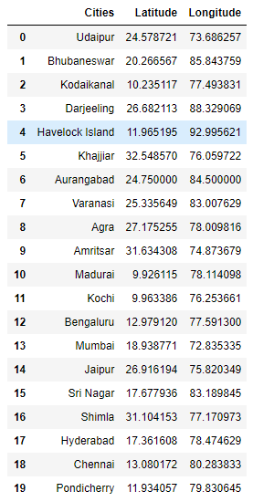

I used python folium library to visualize geographic details of cities mentioned above and I created a map of India with cities superimposed on top. I used latitude and longitude values to get the visual as below:

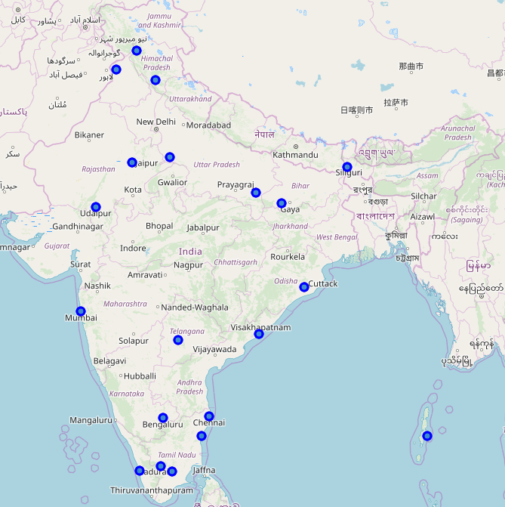

Collect location data First the Foursquare API is used to explore a city and to get trending venues around a point of interest. Another venue query is performed to retrieve venue ratings for each city to find the most popular places. The venue categories choosen for the analysis included Historic Sites, Food, Transport and Travel and Spiritual Centers.

Below is the merged data after all the venues:

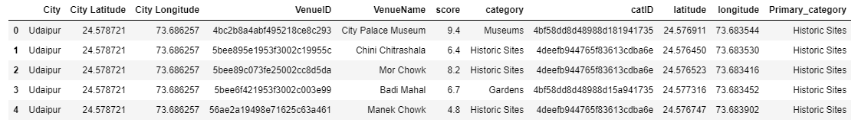



After running the series of sorting and regrouping operation on the above dataframe, I have comeup with the top 10 venues for each city as shown below:

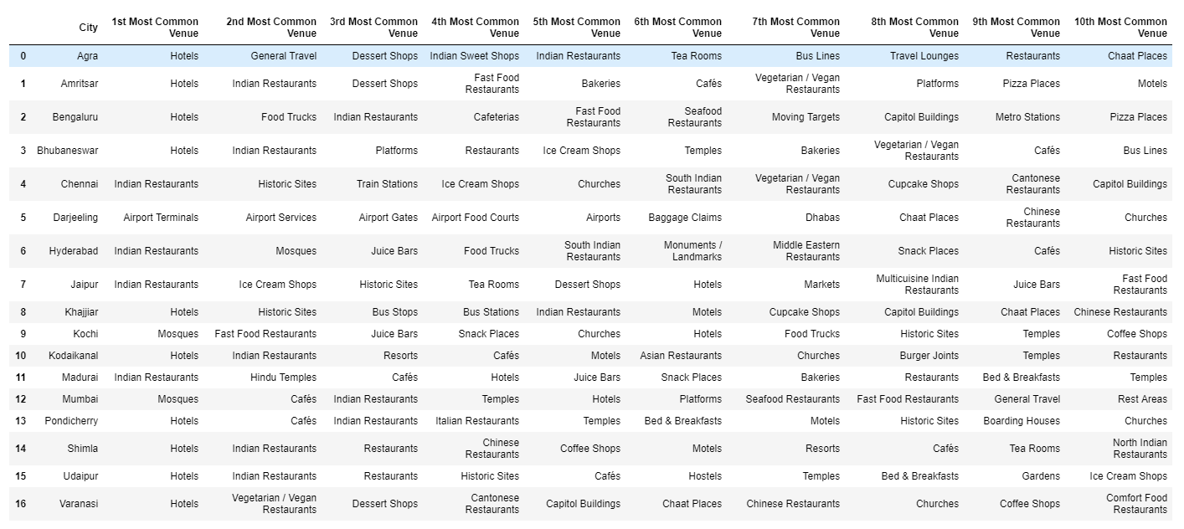

After this step, I have used k-Means clustering to cluster the cities and use Folium to pin the clusters on the Map.

Below is the dataframe with cluster numbers with top 10 venues for each city:

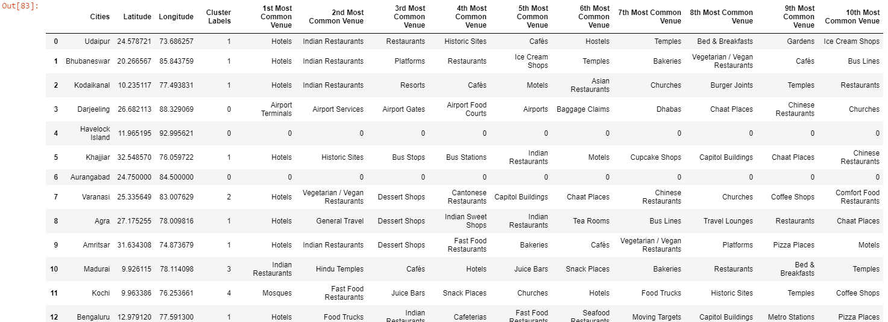

Finally, we have map of India with cities categorized in different clusters:

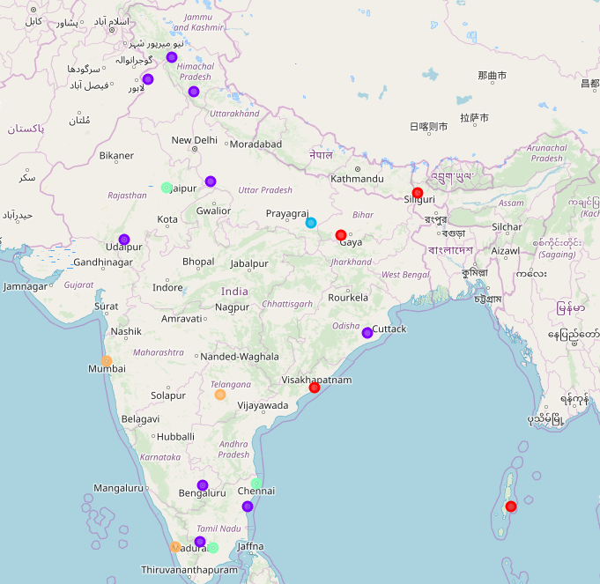

Conclusion: Almost 9 cities are similar : Udaipur, Bhubaneswar, Kodaikanal, Khajjiar, Agra,Amritsar, Bengaluru, Shimla and Pondicherry. These cities are the most visited tourist places with best hotel,Resorts,Transport and Restaurants.

**Cluster 0:**

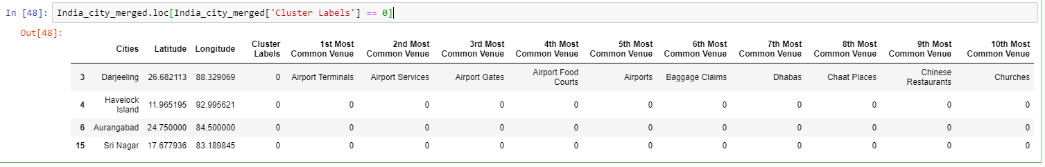

**Cluster 1:**

This is the cluster with most of number of cities.

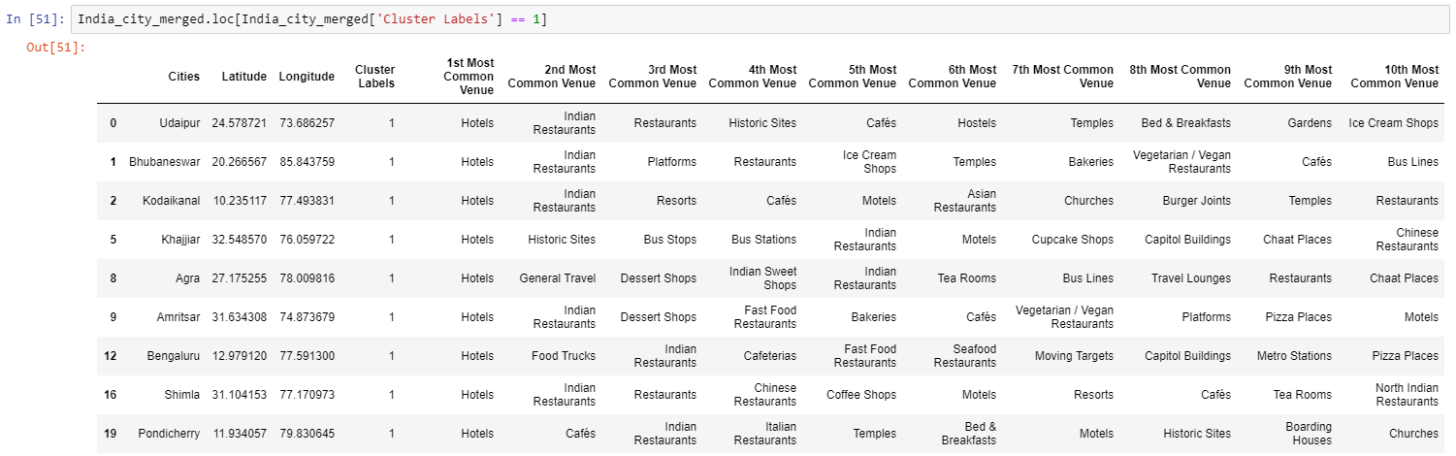

**Cluster 2:**

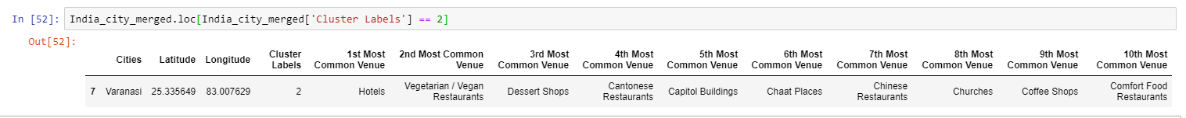

**Cluster 3:**

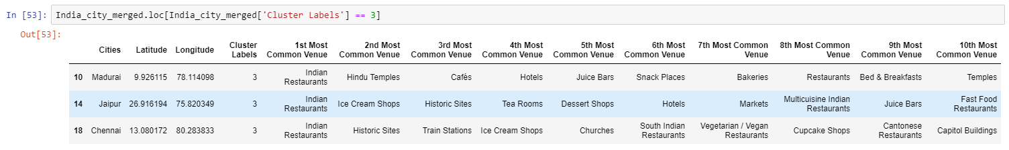

**Cluster 4:**

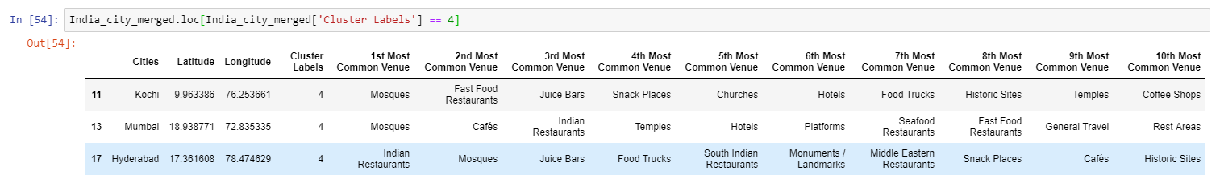

Below is the data visualization of the most common venues:

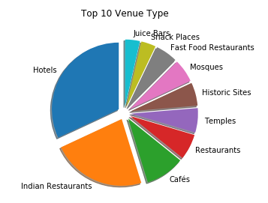 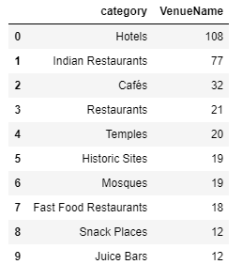

Based in the score/ratings provided by Foursquare, below are the cities in descending order list ad also can be visualized using box plots:

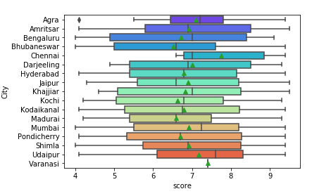 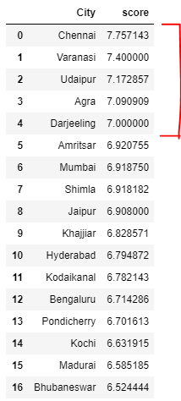

As per the ratings Chennai, Varanasi, Udaipur, Agra and Darjeeling are the top 5 cities to visit.

Using the above data analysis, we can even fetch all the venue information for a single city of tourist’s choice.

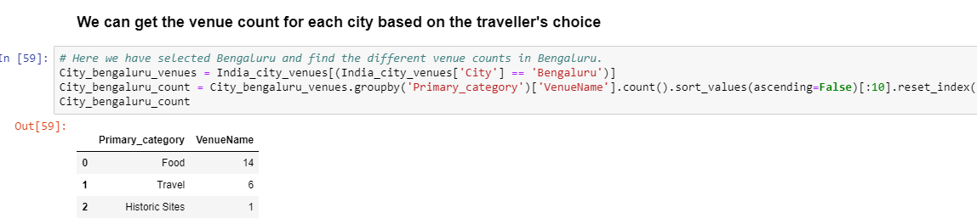

## Conclusion

**Conclusion 1:**

Almost 9 cities are similar: Udaipur, Bhubaneswar, Kodaikanal, Khajjiar, Agra, Amritsar, Bengaluru, Shimla and Pondicherry. These cities are the most visited tourist places with best hotel, Resorts, Transport and Restaurants

**Conclusion 2:** Most of the venue types are Hotel, Indian Restaurants, and Cafes

**Conclusion 3:** As per the ratings Chennai, Varanasi, Udaipur, Agra and Darjeeling are the top 5 cities to visit.

The above conclusion/analysis provides the tourist an overall information of top 20 cities to visit in India and all possible venue information including the Transport/ Historic Sites/Temples and many more. Thus addressing one of the tedious part of travel plan and making the travel, stay and the experience of enjoying the multi-cultural subcontinent much more memorable and hastlefree.